**17/10/2023**

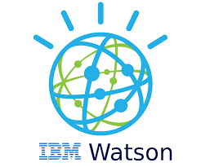

**Machine Learning Model Deployment with IBMCloud Watson Studio**

|  |  |
| --- | --- |
| Topic | Phase 3: Development Part 1 |
| Team Member | 1.HALISH RICHARD J (**TL**)  2. MOHAMED ATHIL M  3. ARUSAMY A  4. RAHUL DRAVID A |

**Prerequisites**

* An IBM Cloud Account
* An account on IBM Cloud Pak for Data.

**Steps**

1. Create a new Cloud Pak for Data project and Cloud Object Storage service
2. Import require Data Set as Train and test for web phishing
3. Build a model with AutoAI
4. Deploy the model with WML
5. Create Job without schedule
6. Run the Job

**Create a new Cloud Pak for Data project**

* Log into IBM's [Cloud Pak for Data](https://dataplatform.cloud.ibm.com/) service.

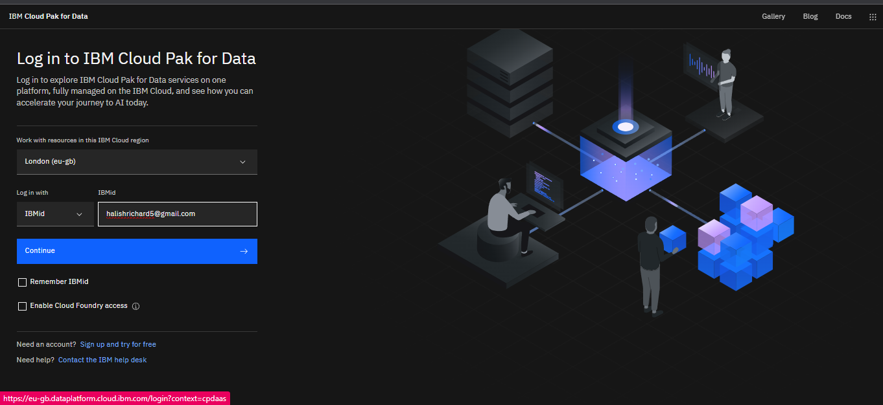

**Fig-1**

* Once in, you'll land on the dashboard.

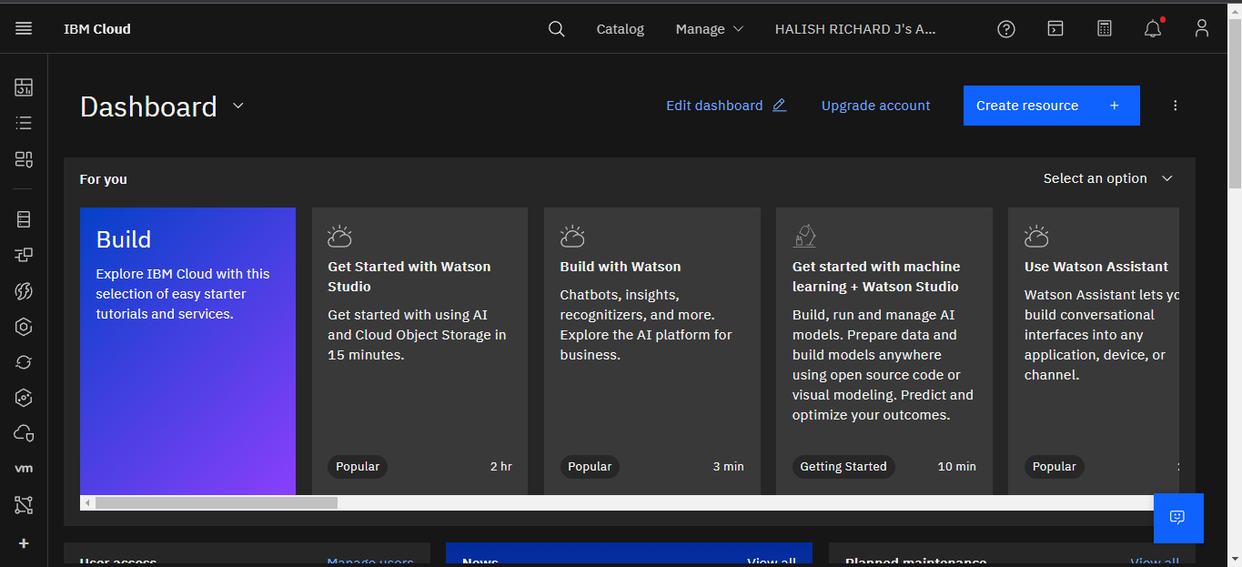

**Fig-2**

* Create a new project by clicking Create a project.

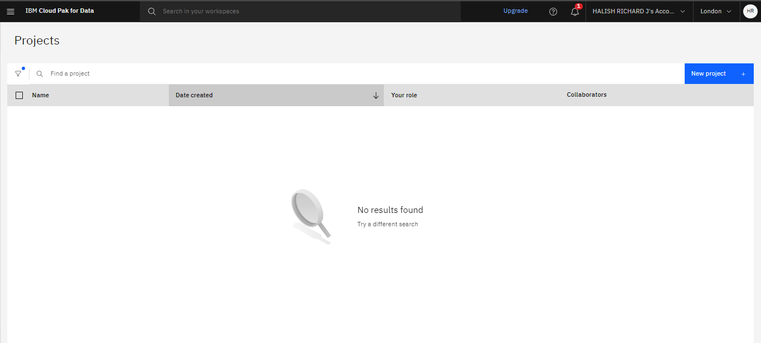

**Fig-3**

* Choose an Empty project.

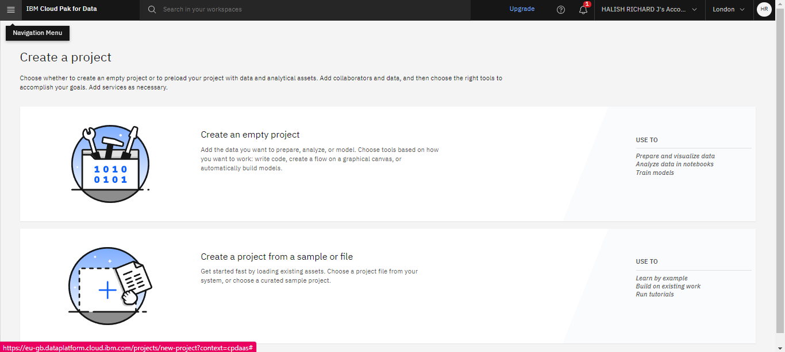

**Fig-4**

* Enter a  Name and associate the project with a Cloud Object Storage service.

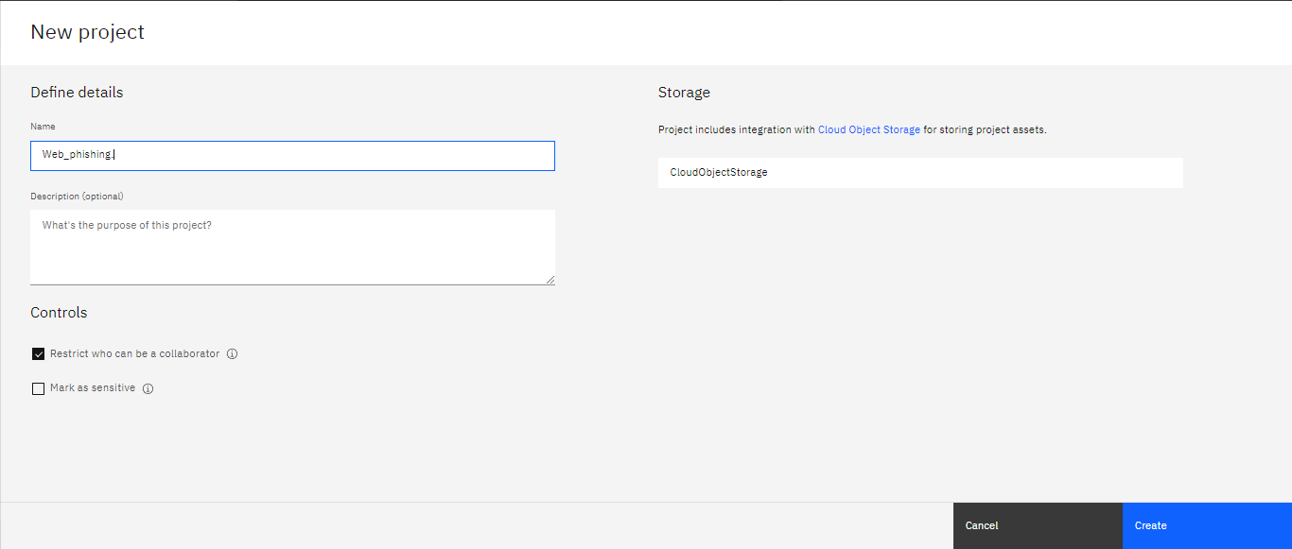

**Fig-5**

* At the project dashboard click on the Assets tab and upload the data set associated.

[dataset_website.csv](https://eu-gb.dataplatform.cloud.ibm.com/projects/6c0c326d-4042-4619-b2dc-fca15946fc78/data-assets/ada65449-8456-4b6f-8923-bf60f16ab9f6?context=cpdaas&walkme_guided_tutorial=false)

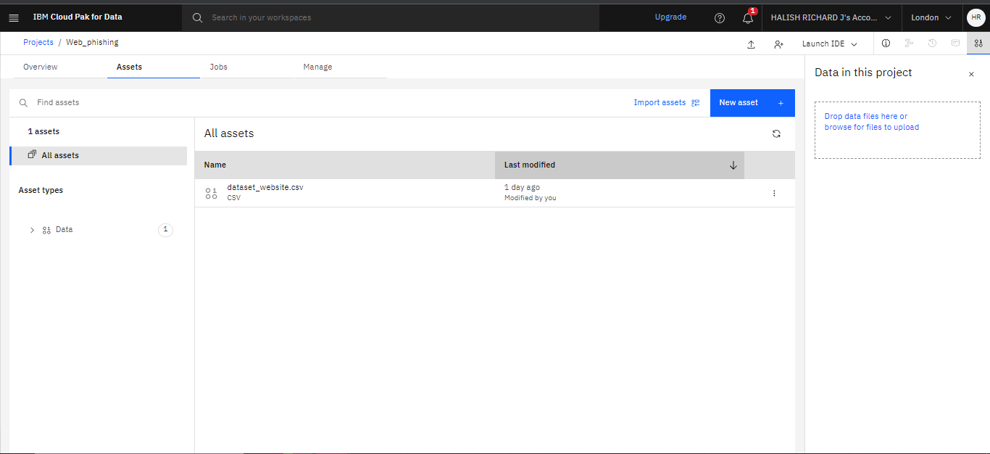

**Fig-6**

**Build a model with AutoAI**

* Now we're going to build a model from the data using IBM's AutoAI. A tool that will automatically create multiple models and test them, giving us the best result. Data science made easy.
* Start by clicking on Add to project and choosing AutoAI experiment.

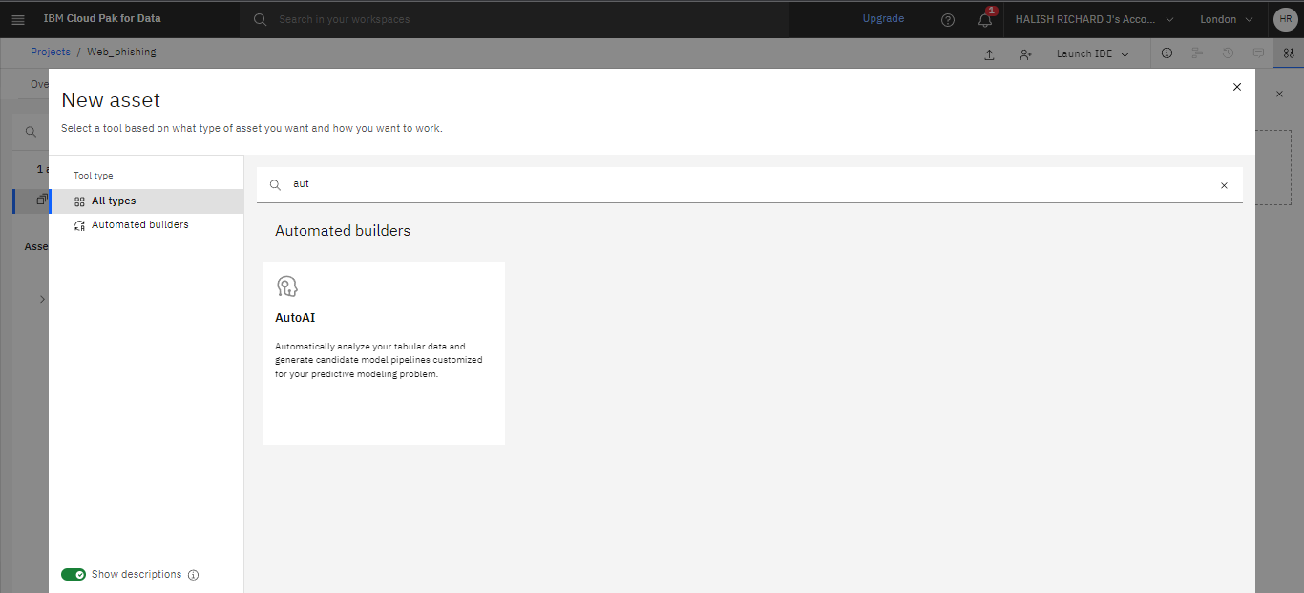

**Fig-7**

* Choose to use data from your project.

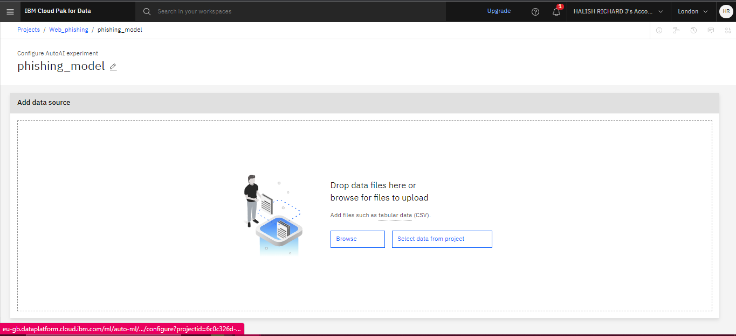

**Fig-8**

* Choose the [dataset_website.csv](https://eu-gb.dataplatform.cloud.ibm.com/projects/6c0c326d-4042-4619-b2dc-fca15946fc78/data-assets/ada65449-8456-4b6f-8923-bf60f16ab9f6?context=cpdaas&walkme_guided_tutorial=false) option.

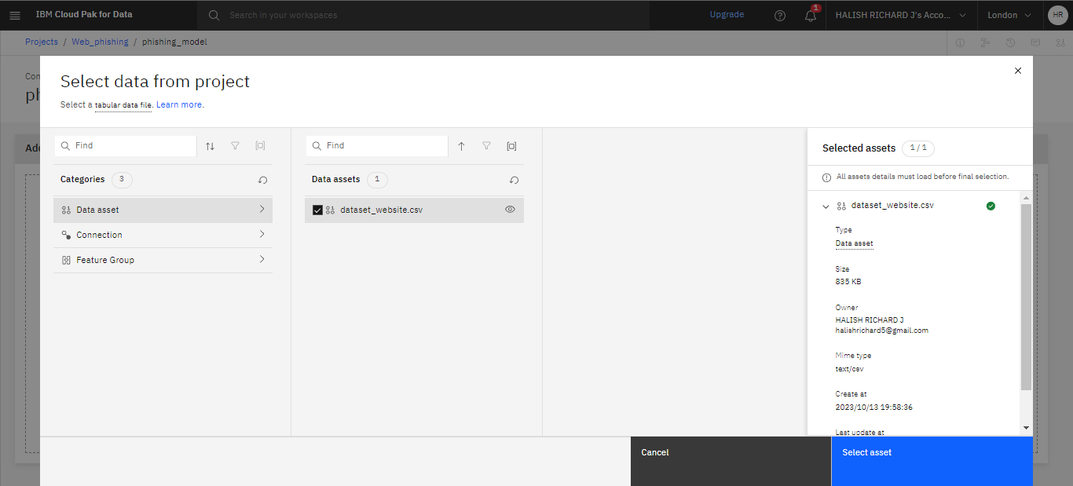

**Fig-9**

test-dataset_website.csv

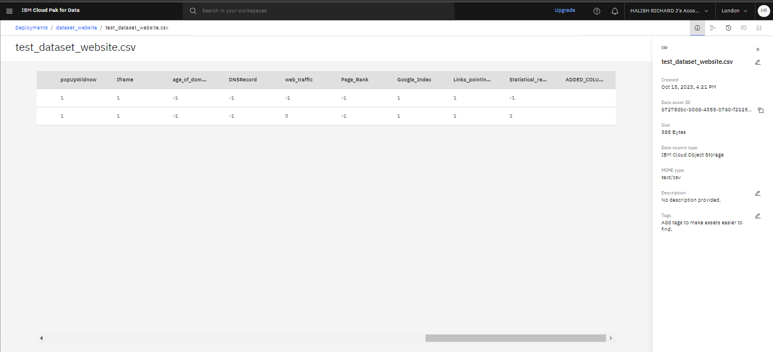

**Fig-10**

* Click “Run Experiment” for create.
* Set prediction column as “Result”.

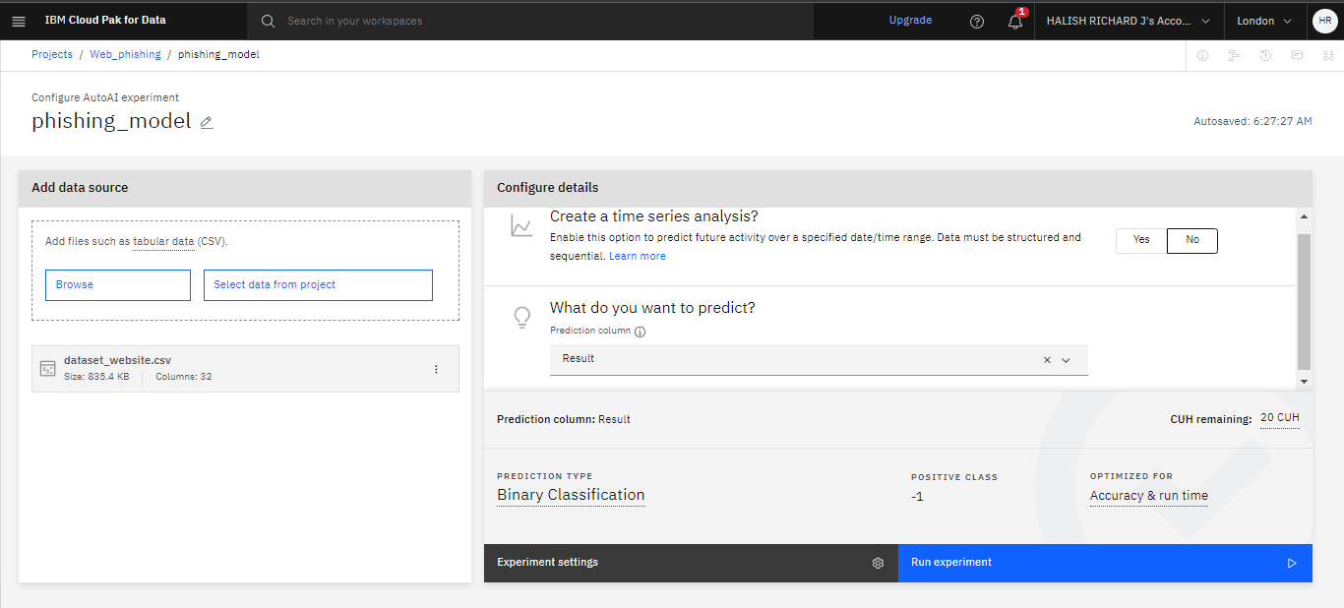

**Fig-11**

* The experiment will take a few minutes to run. Once completed hover over the top option to make the Save as button appear.
* Click it.

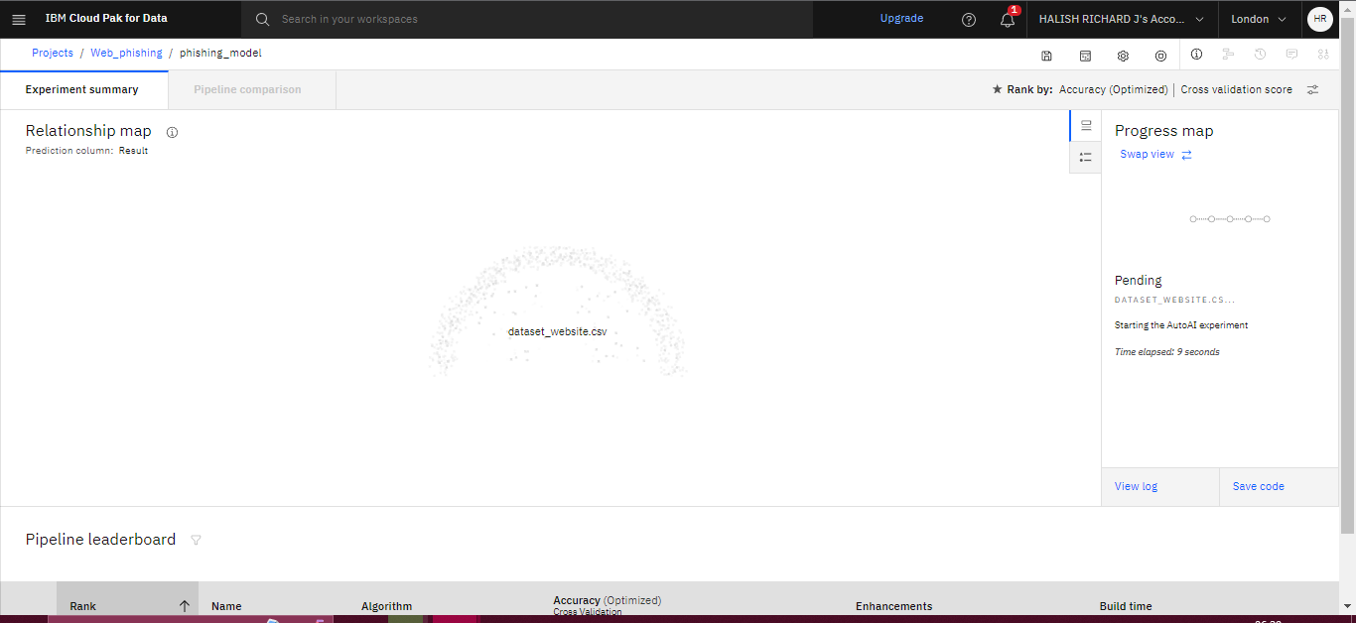

**Fig-12**

* Choose to save the experiment as a Model. You can optionally download a generated Jupyter Notebook that can be used to re-create the steps that were taken to create the model.
* AutoAI also prefer XGBoost Classifier as 0.969 accuracy.

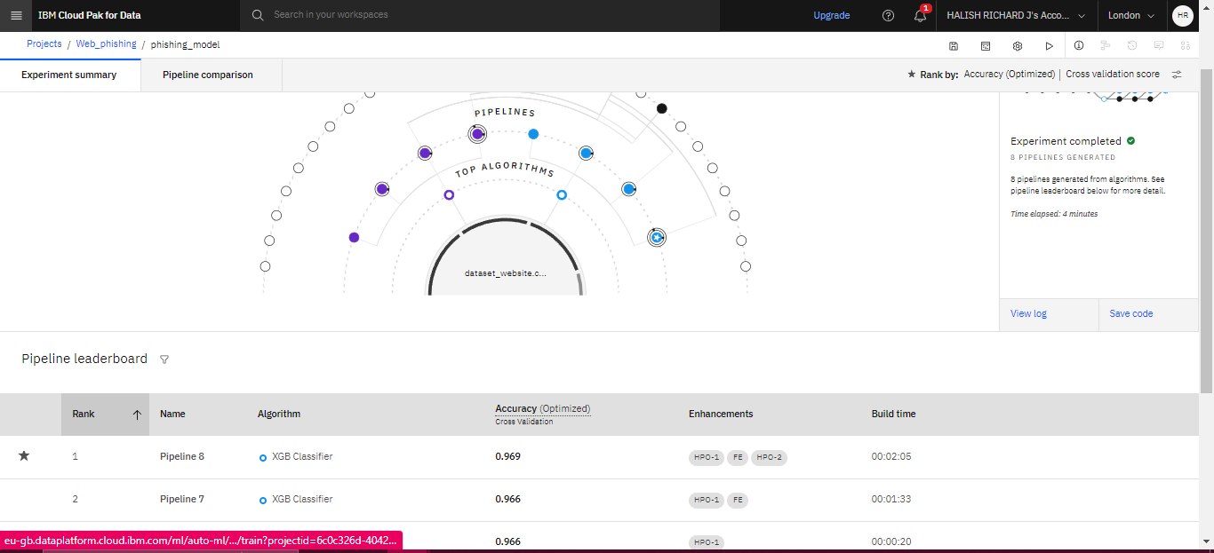

**Fig-13**

* The model will be saved. Choose Model as asset type.
* Click the dialog to view it in your project.

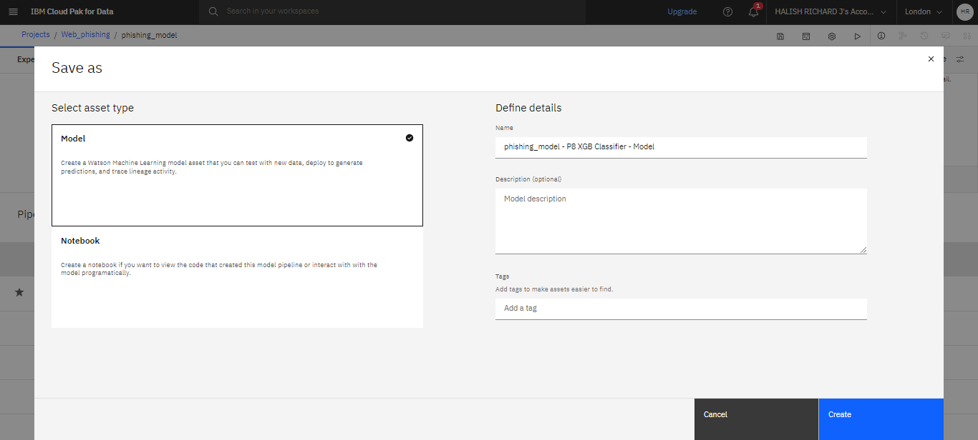

**Fig-14**

* Once you're at the model overview choose the button “Promote to deployment space”.

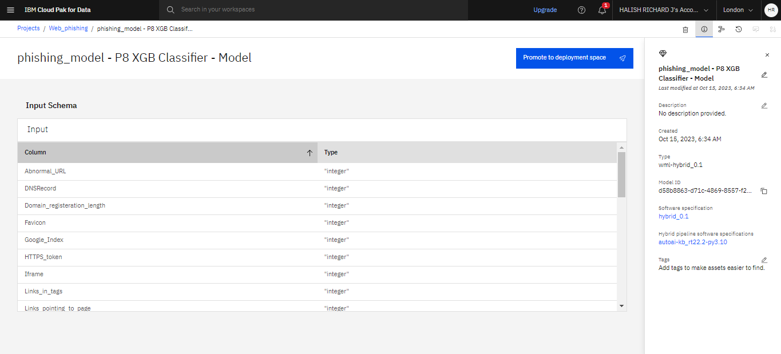

**Fig-15**

**Deploy the model with Watson ML**

* To promote the model to deployment you must specify a deployment space.
* choose the New space + option to create one. This action will associate the model with the space.
* Select Data Model as “phishing_model-PBXGB Classifier-Model”.
* Click Promote.

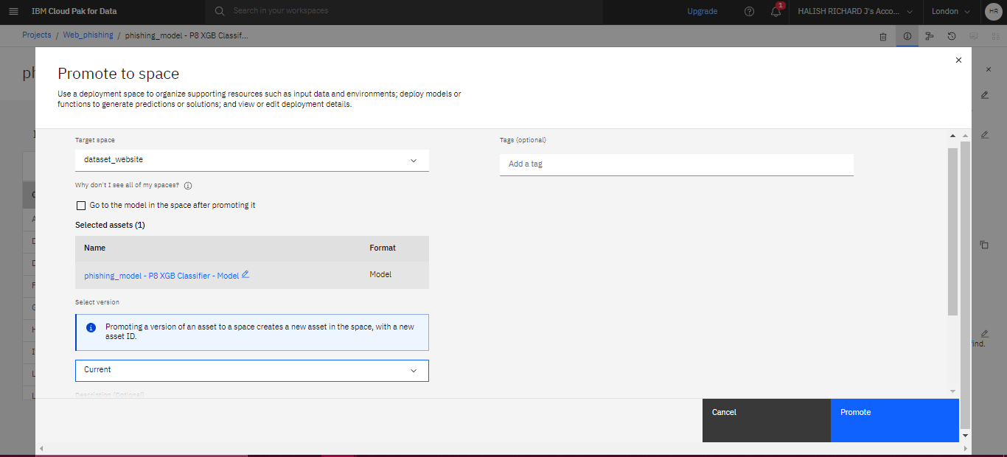

**Fig-16**

* Navigate to the space using the hamburger menu on the top right and

Choose to New deployement space.

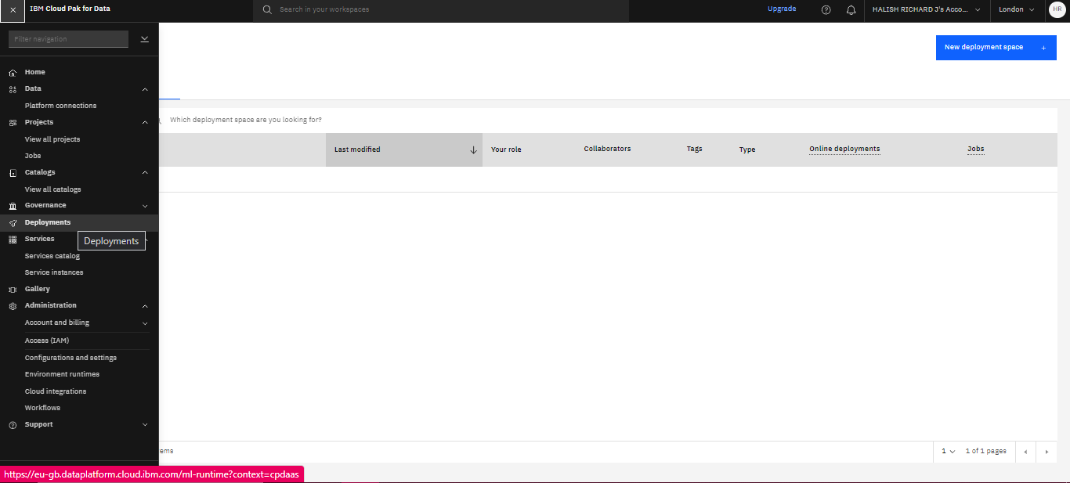

**Fig-17**

* Choose the deployment type as Batch for only manual deployment model.
* Enter name Phishing_deploy.
* Click Create.

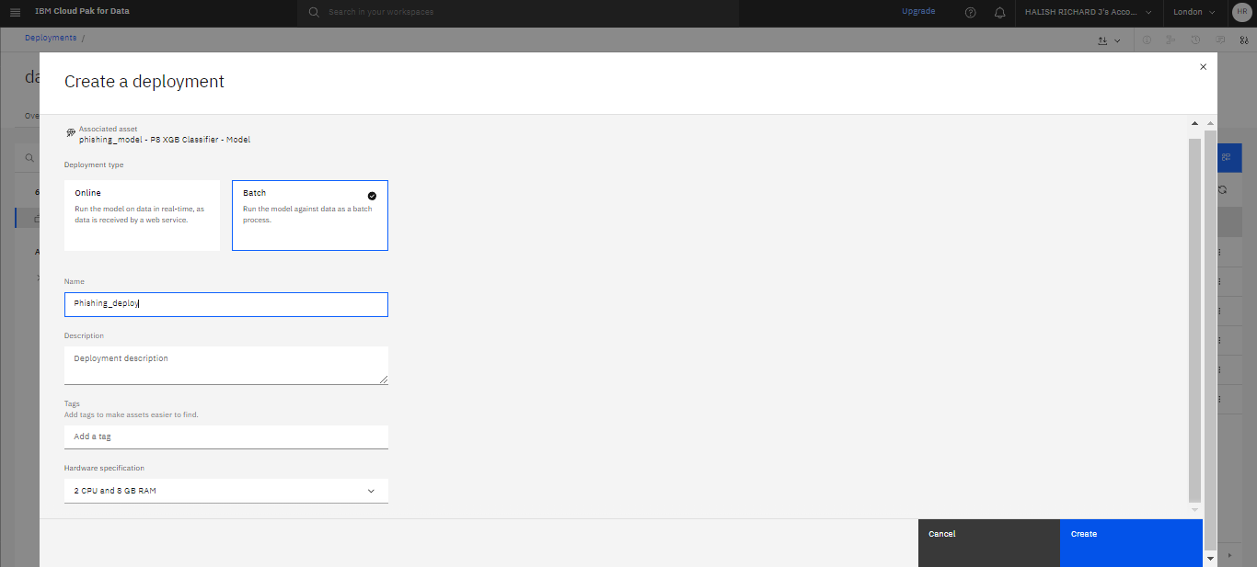

**Fig-18**

* Your new deployment will appear. Click “Phishing-deploy”.
* Click new job for create job without schedules.

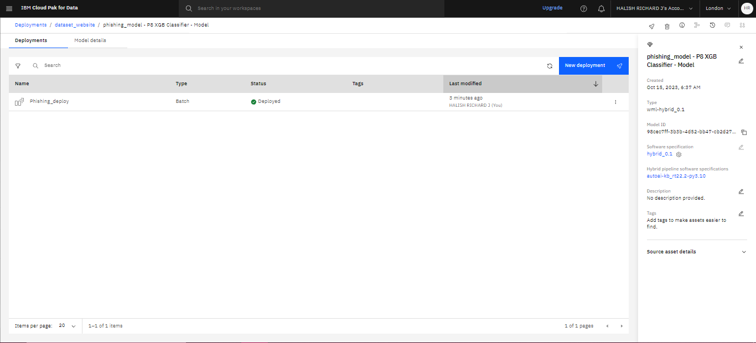

**Fig-19**

* Enter job Name as “Web_phishing_job”.
* Click Next and Next.
* In choose data, Set dataset for train and test.

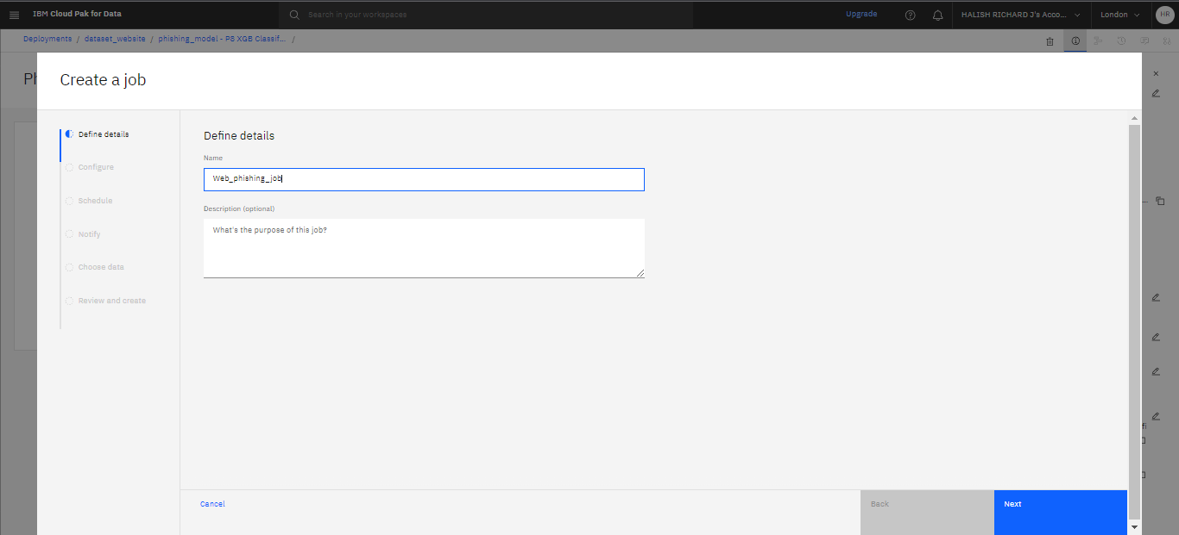

**Fig-20**

* Click run as play button.

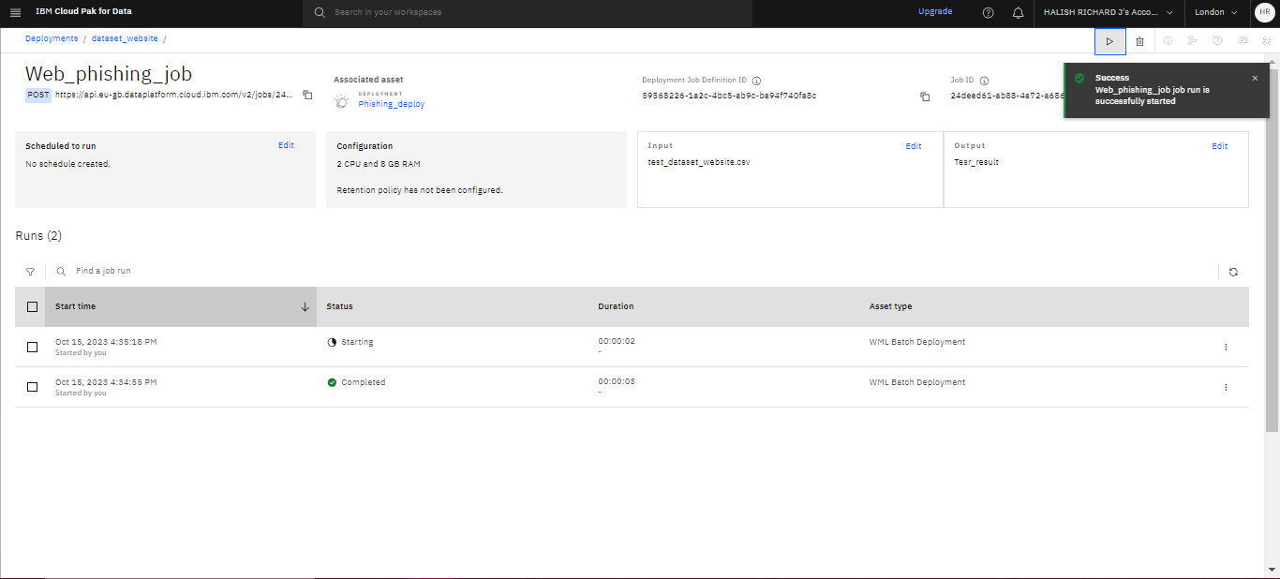

**Fig-21**

* In deployments space occur tesr_result.csv for output That can be predication value.
* We just give two rows dataset in train dataset so the prediction will be two output.

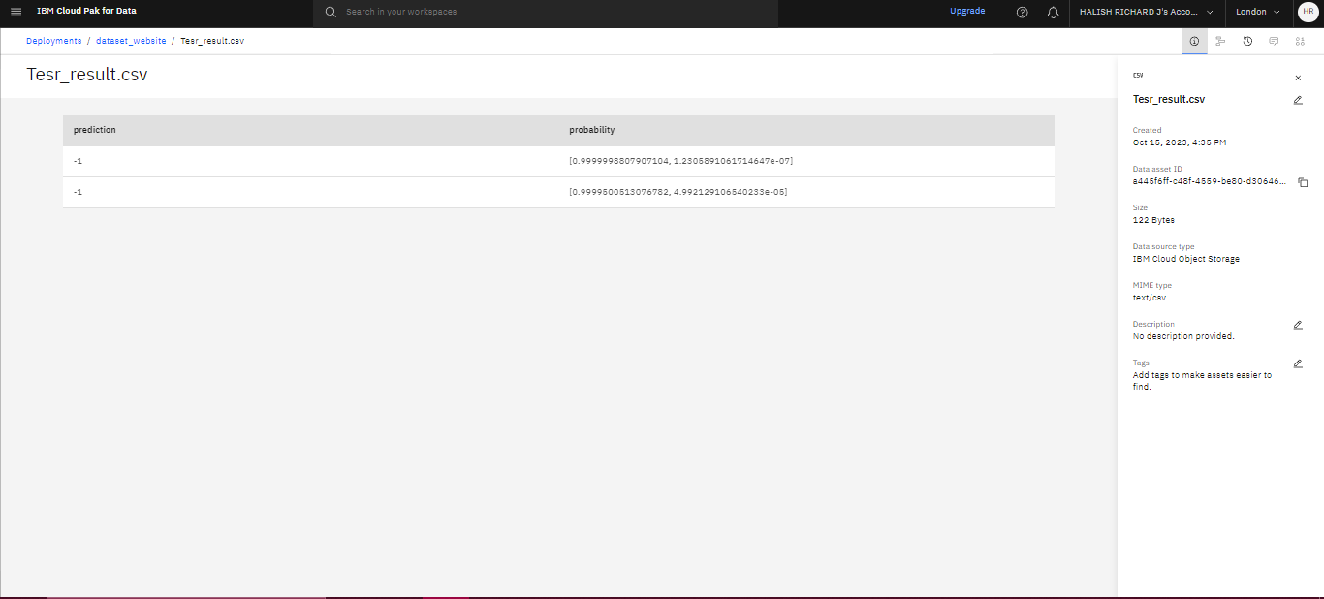

**Fig-22**

If Prediction value positive that is not suspicious or negative that is suspicious.

Refer:

<https://www.kaggle.com/datasets/ahmednour/website-phishing-data-set>

<https://www.ibm.com/docs/en/cloud-paks/cp-data/4.0?topic=services-watson-machine-learning>

Github:

<https://github.com/Halishrichard17/Cloud-Application-Development-NM>